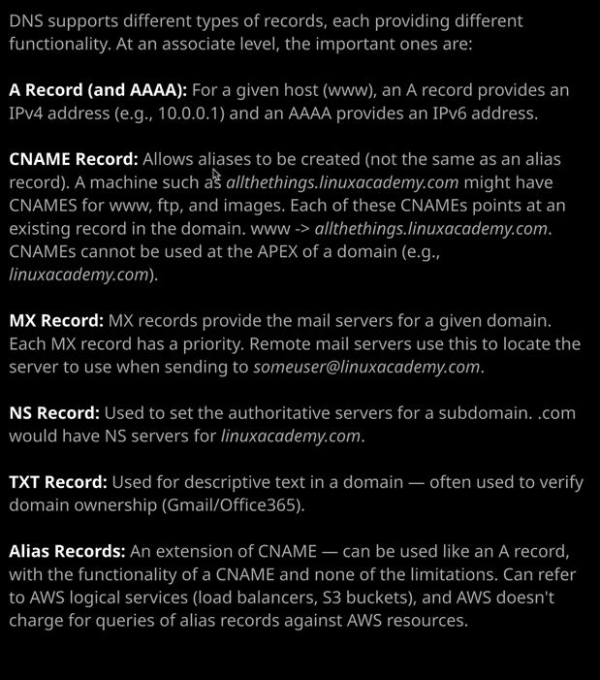

Welcome back and in this lesson, I want to talk about the different type of records that are available inside Route 53 as well as DNS in general. Now, I'm going to cover these fairly quickly. I'm just going to talk about the theory because we'll be utilizing these extensively as we go through the course. So I don't need to double up and give you the practical experience now, because you'll get those later in the course.

The first record I want to talk about is an A record, **and A record essentially translates a given host name to an IP address.** So all of the records that have created so far inside associatecats.com have been A record. So I created a www A record that mapped to a specific IP address and that's what an A record does it maps a host to an IP **an A record is the IP version four address so**, for example, 10.0.1. whereas an **AAA record maps to an IP version six address**. So they're the same thing. They just map to a different version of IP.

The next type of record is a **cname record and a cname allows you to create aliases**. Now, an example of this is you might have a DNS record of serverone.linuxacademy.com That server might fulfill a lot of different functions. It might be an FTP server. It might be a web server. It might be a VPN server. What you could do is **create individual A records one for www and for FTP and one for VPN and have them all pointing at the same IP address but they would be individual records, and any time the IP address changed, you'd have to look day all of those records. What cnames you allow you to do is to reference an existing record.** So what we could do is we could create this server one A record and have that pointing at an IP address and then we could create a cname for FTP and point it at server one. We could create a cname for www and point it at server one and the same for VPN. When we do that, it means we only have that one original record to edit. **So if you change the IP on that one original record than all of the cnames because they're still pointing at that original record are automatically updated.** Now cnames do have some important considerations. You can use cnames to reference records inside the domain that you're in, and you can do that by just specifying the hostname so www. **You can reference names that are outside your domain but if you do that, you need to specify the fully qualified domain name and an example of that might be allthethings.linuxacademy.com and then dot** so you need to specify that last dot to indicate that it's a fully qualified domain name. Another consideration is that a **cname cannot be used for a make domain, also known as the apex of a domain. So you could use a cname for www.linuxacademy.com but you couldn't use it for just linuxacademy.com**, and it's fairly popular these days. Instead of going to www dot something, you just go to the domain name. Netflix.com, linuxacademy.com, and if you do want that, you can't use cname. It's just a limitation with the DNS standard.

Next, we've got ***MX records*** and MX records provide the mail servers for a given domain. So if I go to create records set and then change the type to MX, which stands for mail exchange what we do for this domain—so this is associatecats.com— we specify a list of values. The first value is numeric. That's a priority value and the second value is a DNS name of a mail server. Now, the way this works is whenever an email server is attempting to send mail to your domain, it does a query at the MX records for your domain, and it preferences ones that have a lower priority value. So it selects the lowest priority value, gets the DNS name for that mail server so it gets that value, resolves it and then attempts to connect to it using a mail protocol such as SMTP.

Next we've got **ns records** and these are the records that are used by DNS to delegate authority for a domain. If you recall when I registered associatecats.com what actually happened was these names servers were created and allocated to this domain, and they were supplied to the operator of the dot com zone. So we provided them via Route 53 was an automatic process when we registered the domain, but they were provided with these names server values. So the record for associatecats.com inside the zone file off the dot com domain contains these names server records so they're used for delegation. **Whenever you want to allocate authority for a certain sub domain to somebody else, you simply create a record, specify the name servers that they give you, and then DNS knows that you trust that lower level it's essentially delegation.**

Next, we've got **txt records** on their records that you **used to store plain text inside a domain**, these can store any text that you want, but they're often used to verify domain ownership. So if you're ever adding a domain to Gmail or Office 365, they'll probably ask you to add a text record to the domain with some random text that they're aware of and they can perform a resolution on that text record, match the text of that text record, and if it matches, it guarantees that you own that domain. You've got the ability to update the records, so you prove ownership but text records can be used for many other things such as spam filtering any application configuration. It's actually a really flexible record type. You can store anything that you want in there and have it available to anyone doing DNS queries against your domain.

Now, lastly, we've got Alias records and Alias records are, in a way, an extension of a cname. Alias records are something that AWS have added to Route 53 and they go beyond the standard DNS record types. Aliases behave like cnames in that they reference others things. So AWS services such as S3 buckets, load balancers, CloudFront distributions, and many other services and don't worry. I know we haven't covered some of those yet, but you will do later in the course. If I go back to hosted zones and open associatecats.com I'm going to create a record set. Now for all of the different types of records that so for example cname or A record. You've always got the ability to select an alias type for that record, and if you do that, you can click in target name and you're presented with any available AWS services, and you can select those. **Now what an alias actually does, it provides the same level of functionality as a cname. So instead of directly pointing at an IP address an alias points at a logical service provided by AWS.** Now, the exact way that an alias works depends on the AWS resource. So, for example, if you give it a CloudFront distribution then Route 53 response with the IP addresses for the CloudFront distribution that can serve that content. If you give it a load balancer, then it will respond with one or more IP addresses for that load balancer but you can also give it an S3 bucket and we'll see that in the next topic of the course but essentially **the advantages of the alias record type is that you can use it for the naked domain** so netflix.com, linuxacademy.com, bestcatpicsintheworldever.com, you can use that on the **apex of the domain, the naked domain in the same way that you might use a cname only you can't use cnames in that position. So it extends the functionality of cnames but perhaps more importantly, is the AWS don't charge for using aliases.** So when you're doing DNS queries with all of the other record types, there is a very, very small charge per request. Now you can do millions and millions of requests and hardly see that on your AWS bill. So we're not talking a huge amount of money but if you do use aliases, it is entirely free. AWS do have a preference for you to use aliases. I recommend using aliases in most cases but I do try to illustrate that it is a Route 53 specific feature. So if you're using third parties to host your domains and integrate with AWS, you won't have the ability to use aliases. So you need to be aware of these nuanced differences between aliases and cnames and aliases and A records. Okay, so that's the end of this lesson. I've covered all of the theory that I wanted to cover. I know it is only theory, but I will be using a Route 53 records extensively throughout the course. So you will have plenty of opportunities to use these in realistic environments. You will get that practical exposure but at this point in the course, I just wanted to introduce the theory so that you're comfortable with the different usages of DNS. So go ahead, mark this lesson as complete and when you're ready, I'll see you in the next.